Intermediate Algebra Lecture 11.1: Solving Quadratic Equations By Completing the Square

Quadratic:
Largest power in equation will dictate how many possible solutions

If you take a square root you MUST have a this will give two solutions

2nd degree equation
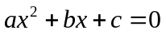

Example
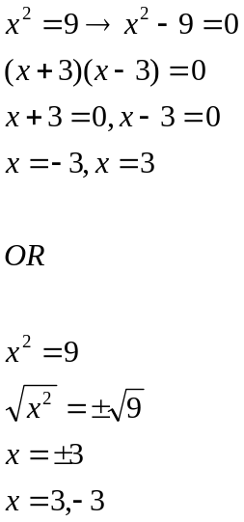

Example
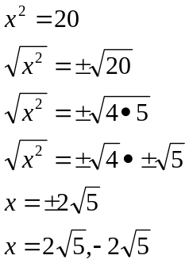

Example
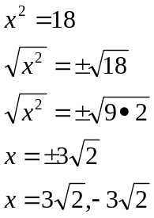

Isolate the square
Example
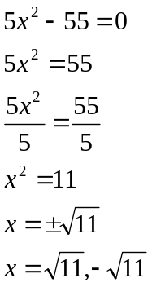

Example
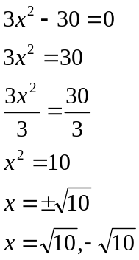

Example
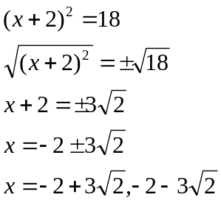

Example
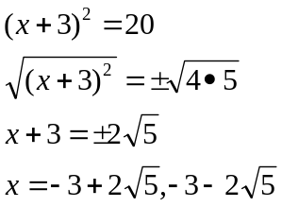

Example
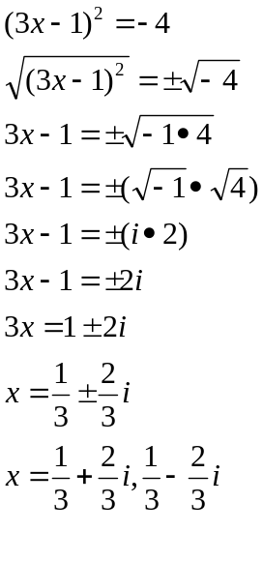
Example
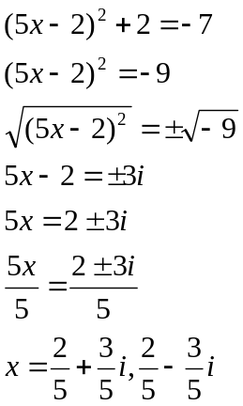

Completing the square:

Steps:
- Set up equation so that the “x-terms”
are on one side and the constants are on
the other.

- Make sure the co-efficient of the 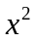 term is 1
divide if necessary.

- Add the square of 1/2 co-efficient of the “x” term
to both sides of the equation

- Factor (perfect square trinomial)

Example
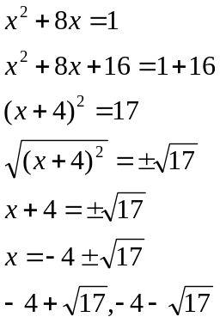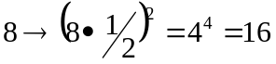

Example
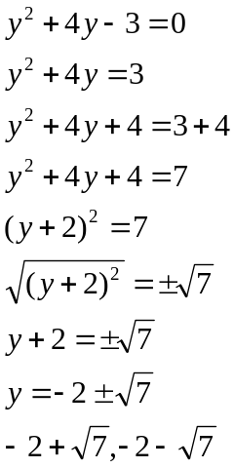 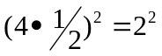=4

Example
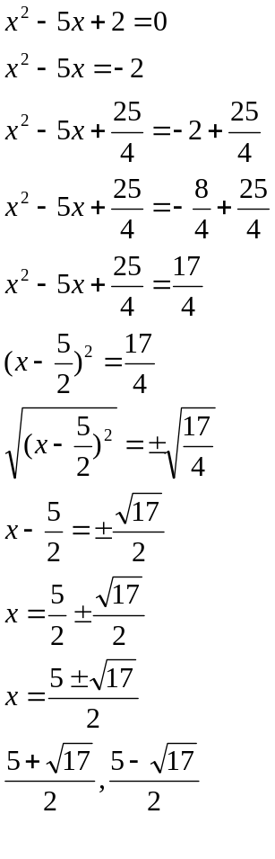

Example
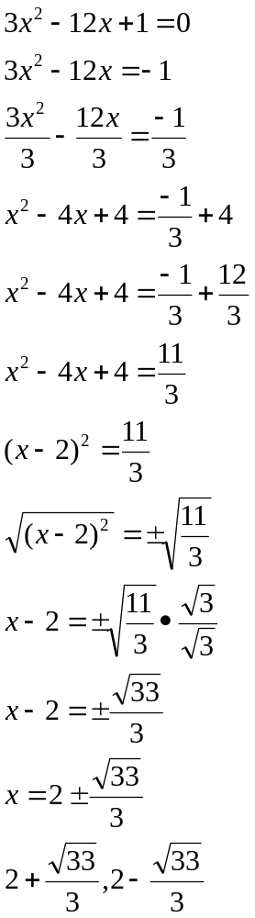

Example
